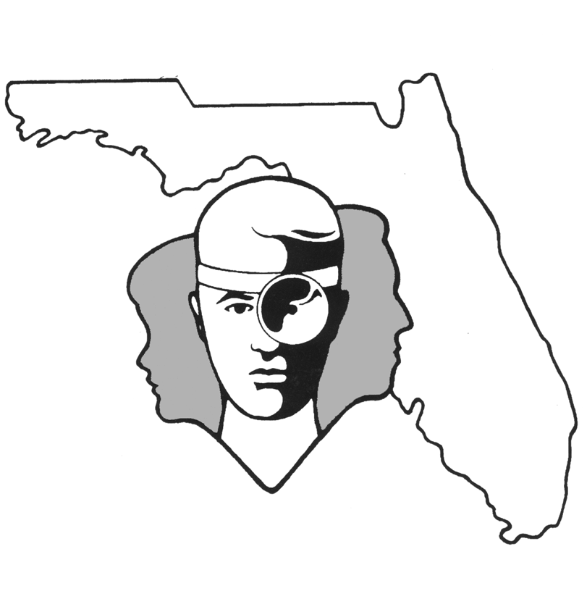

TALLAHASSEE EAR, NOSE & THROAT - HEAD & NECK SURGERY, P.A.

www.TallyENT.com Office Phone: 850-877-0101

PATIENT DISCHARGE INSTRUCTIONS: GENERAL BIOPSIES or EXCISIONS
POST-ANESTHETIC CONSIDERATIONS: If you have had a general anesthetic, it will be in your body 24 hours, so you may feel a little sleepy. This feeling will slowly wear off but, for the next 24 hours adults should not:
- Drive a car, operate machinery or power tools  Drink any alcoholic beverages
- Take any medication except as directed  Make any important decisions – such as signing legal documents
Certain anesthetics and pain medications may produce nausea and vomiting which usually resolves by the evening of the surgery. If your surgery was done under local or using sedation only, then you may have fewer reactions.

ACTIVITY: You can increase activity to normal levels as tolerated. If you have a more extensive procedure, use common sense in terms of the amount of activity you do.
DIET: Progress to a regular diet as tolerated. It is better to start with liquids such as Ginger Ale or apple juice, then soup and crackers, and gradually advance to solid foods.
WOUND CARE: It is not uncommon to have steri-strips or sutures or staples, or a gauze dressing over the incision site. You may remove the gauze dressing the day after the procedure or change it sooner should it become soaked with blood. Other than cleaning, please leave the sutures or staples alone. If the edges of the steri-strips become soiled or curl up you may trim them – do not remove them. There may be times the surgeon will need to place a drain. If you have a drain, please follow your surgeons instructions. Your surgeon will have asked you to check for the amount of drainage every 8 to 12 hours and keep a record of this if you have a suction drain. Make sure you understand how to keep the suction device operative by squeezing and keeping it carefully capped. All of these items should be removed only in the office at your follow up visit. Beginning the day after the surgery, you can clean the exit point of the drain and the incision with peroxide and a Q-Tip or mild soap and water, and apply antibiotic ointment three to four times a day. You will find this is easier as each day passes. We would like for you to keep the wound dry for 48 hours.
MEDICATIONS: In general, you will probably have a prescription for a pain medication and sometimes an antibiotic. Any antibiotic should be taken as prescribed for as many days as your surgeon has recommended. You may take Tylenol, ibuprofen, naproxen or any pain medication prescribed by your surgeon. DO NOT take Tylenol WITH the prescribed pain medication at the same time.
SYMPTOMS TO EXPECT: You can expect moderate discomfort the first night. This should improve each day. There may be a mild fever, but generally not above 101.5 degrees after the first night. There will be a mild bit of swelling during the first 24-36 hours. You may have a mild sore throat from the general anesthetic. There may be a mild bit of bloody oozing during the first night, but this generally resolves by the next day.
WHEN TO CALL YOUR PHYSICIAN:
- If there is increasing pain, redness, or swelling around your incision (signs of infection) after the first two or three days
- A temperature of more than 101.5 degrees at any point

SPECIAL INSTRUCTIONS: A postoperative appointment has already been scheduled. Please refer to your Surgery Information Sheet or call the office to confirm the appointment date and time. We strongly suggest that a responsible adult be with the surgical patient the rest of the day and also during the night for the surgical patient's protection and safety. Children should rest at home, but may be up and about according to doctor's instructions. Please contact your physician immediately if any emergent problems occur. If you find that you cannot contact them, but feel that your signs and symptoms warrant a physician's attention, go to the nearest emergency room. For non-emergent questions (i.e. appointments or general questions), please call during normal office hours.

